We have 7 of these @$250 each. Please inquire about them at Mvcd@mountainviewcolonialdewitt.com
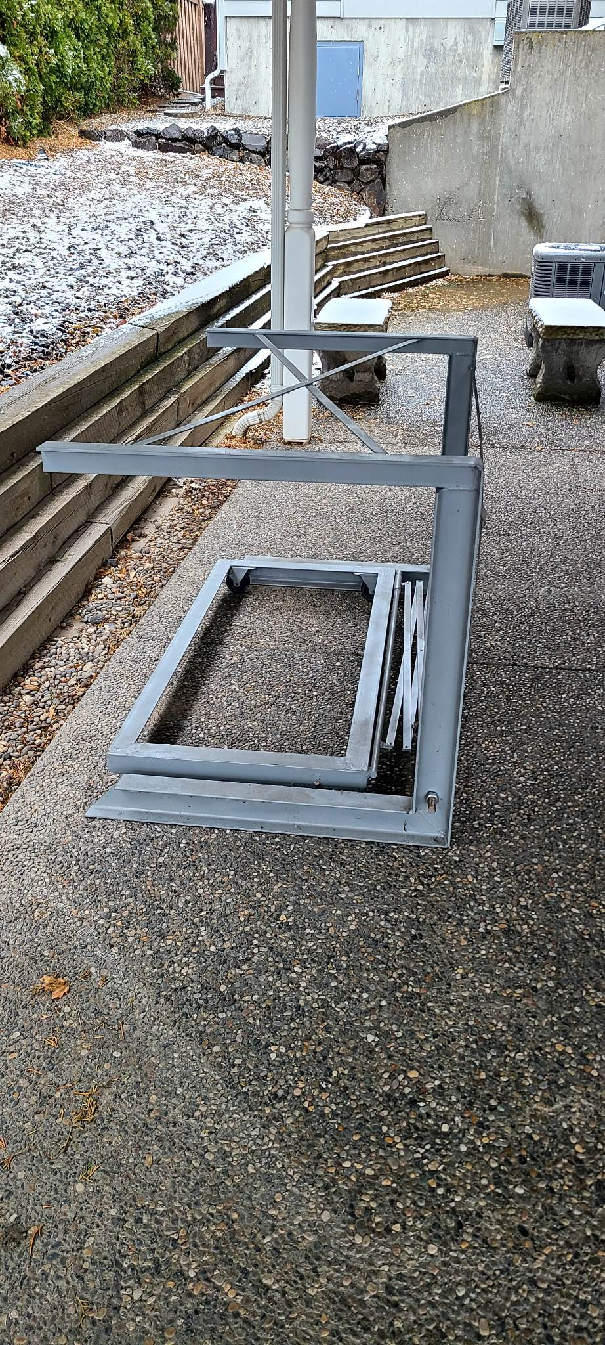
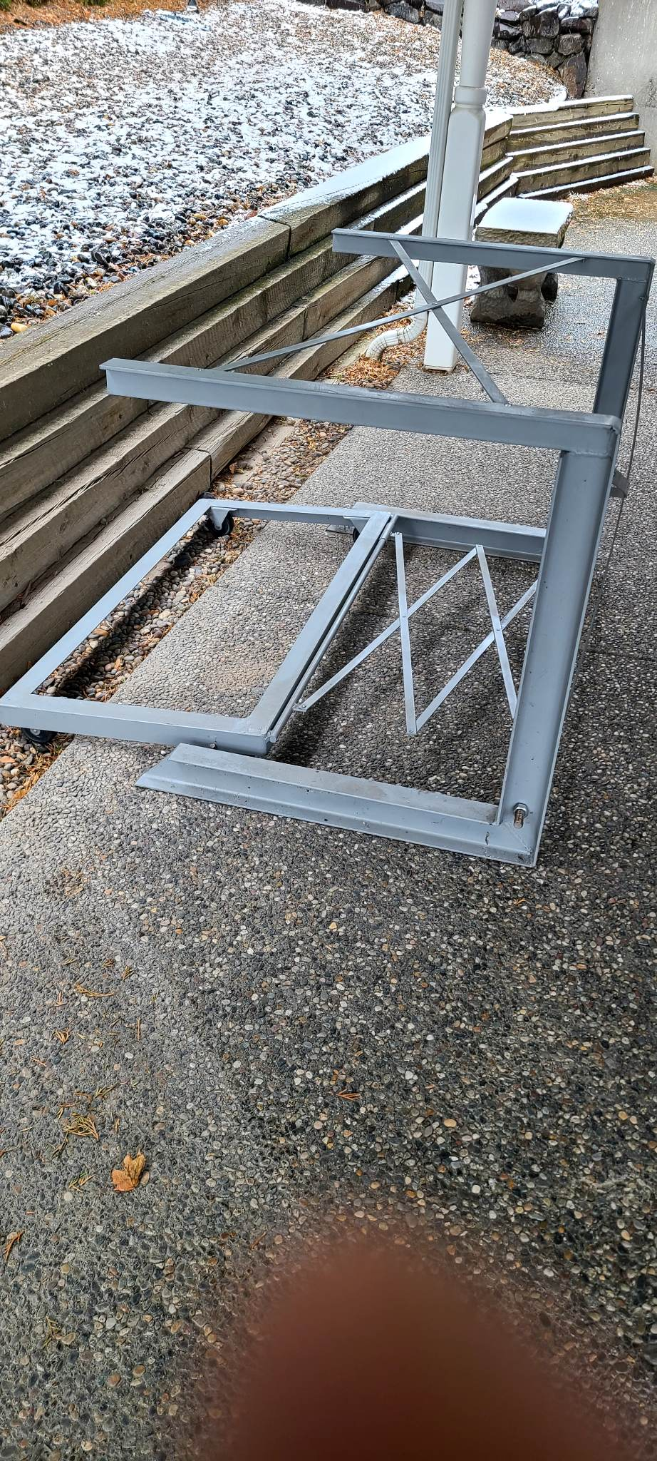
or 509.525.3397

